**Contenido**

**Punto 1 | Perros** 2

**Punto 2 | Pokémon** 4

**Punto 3 | Rick & Morty** 5

**Punto 5 | Nuestro propio API, ¿Cómo hace el animal?** 7

# **Punto 1 | Perros**

Captura Imagen:

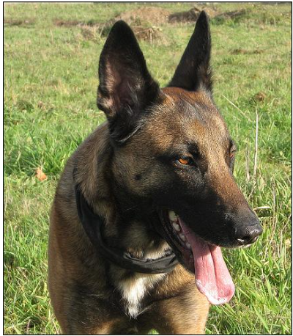

URI Utilizada: https://dog.ceo/api/breed/mountain/images/random/3

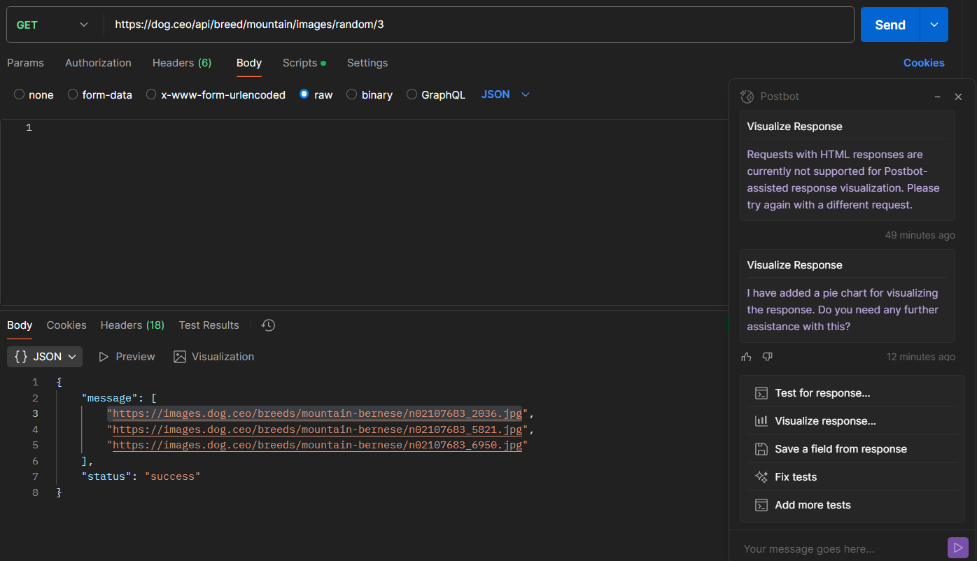

JSON:

{

    "message": [

        "https://images.dog.ceo/breeds/mountain-bernese/n02107683_2036.jpg",

        "https://images.dog.ceo/breeds/mountain-bernese/n02107683_5821.jpg",

        "https://images.dog.ceo/breeds/mountain-bernese/n02107683_6950.jpg"

    ],

    "status": "success"

}

Imágenes Perros:

Enlace #1: <https://images.dog.ceo/breeds/mountain-bernese/n02107683_2036.jpg>

Enlace #2: <https://images.dog.ceo/breeds/mountain-bernese/n02107683_5821.jpg>

Enlace #3: <https://images.dog.ceo/breeds/mountain-bernese/n02107683_6950.jpg>

Fotos Perros:

|  |  |  |
| --- | --- | --- |
| Enlace #1 | Enlace #2 | Enlace #3 |
|  |  |  |

# **Punto 2 | Pokémon**

Sprites:

* <https://raw.githubusercontent.com/PokeAPI/sprites/master/sprites/pokemon/back/25.png>
* <https://raw.githubusercontent.com/PokeAPI/sprites/master/sprites/pokemon/25.png>
* <https://raw.githubusercontent.com/PokeAPI/sprites/master/sprites/pokemon/female/25.png>

Captura:

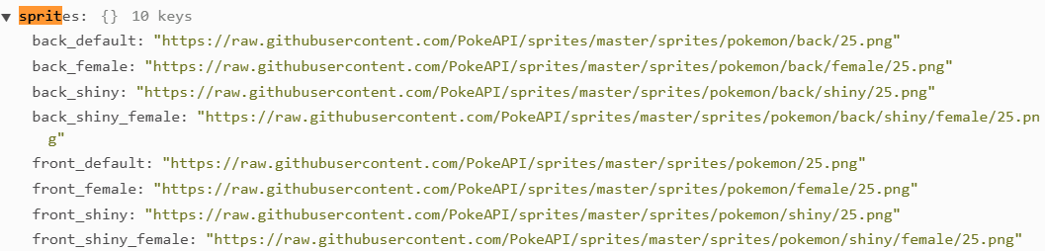

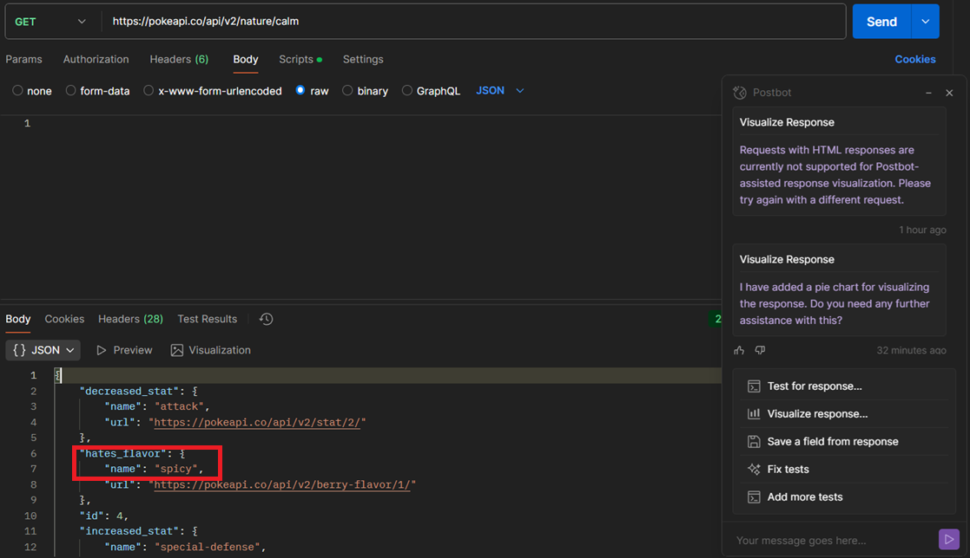

R/ La naturaleza calmada de los Pokémon no les gusta los sabores picantes – Spicy en inglés.

# **Punto 3 | Rick & Morty**

URI Utilizada: https://rickandmortyapi.com/api/location/?name=Dorian

JSON:

{

    "info": {

        "count": 1,

        "pages": 1,

        "next": null,

        "prev": null

    },

    "results": [

        {

            "id": 29,

            "name": "Dorian 5",

            "type": "Planet",

            "dimension": "Replacement Dimension",

            "residents": [

                "https://rickandmortyapi.com/api/character/93",

                "https://rickandmortyapi.com/api/character/104",

                "https://rickandmortyapi.com/api/character/198"

            ],

            "url": "https://rickandmortyapi.com/api/location/29",

            "created": "2017-12-01T11:36:16.463Z"

        }

    ]

}

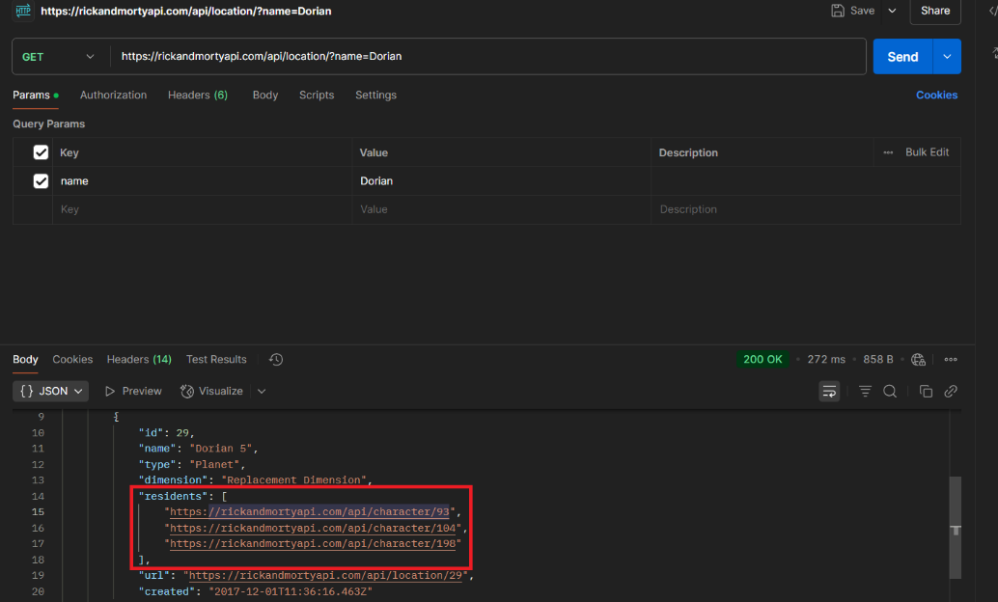

# **Punto 5 | Nuestro propio API, ¿Cómo hace el animal?**

Perros:

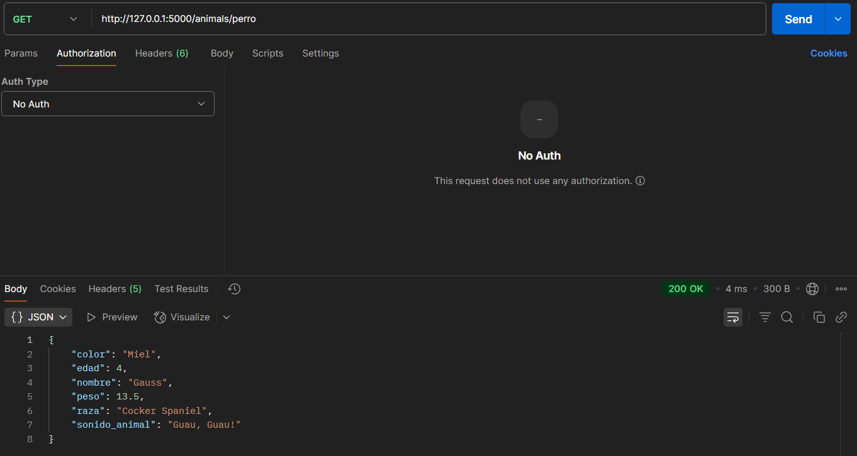

Huron:

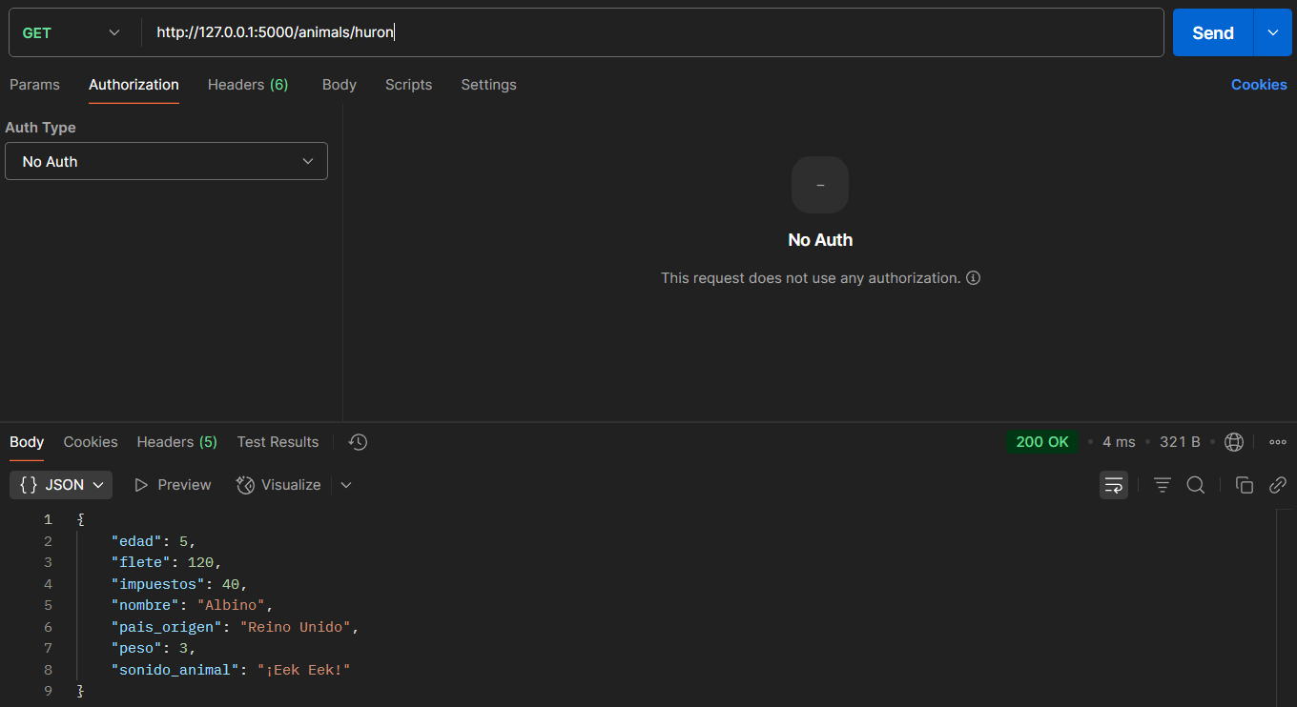

Gato:

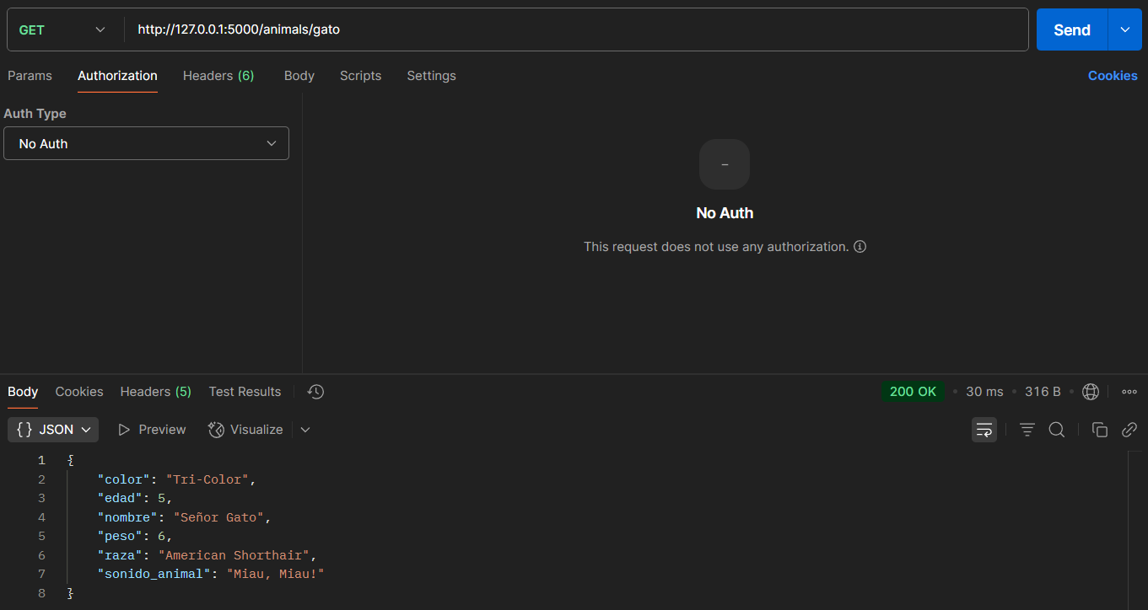

Boa Constrictor:

